**CICD EXPERIMENT – 7**

**Create pipeline using Blue Oceans Plugin**

1. Start the Jenkins service and go to localhost:8080 on a web browser
2. Go to Manage Jenkins and then to Manage Plugins. Find Blue Ocean Plugin and install it
3. After installation, Blue Ocean option will be visible in the dashboard. Select Blue ocean option
4. Now you are required to choose options as per your convenience and hit “Create Pipeline” button

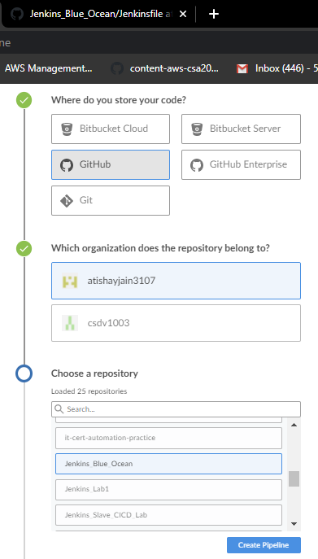

1. Now go to your github repo and search for the Maven project for which you want to build a pipeline. The project should contain “Jenkins File”(create if not already)

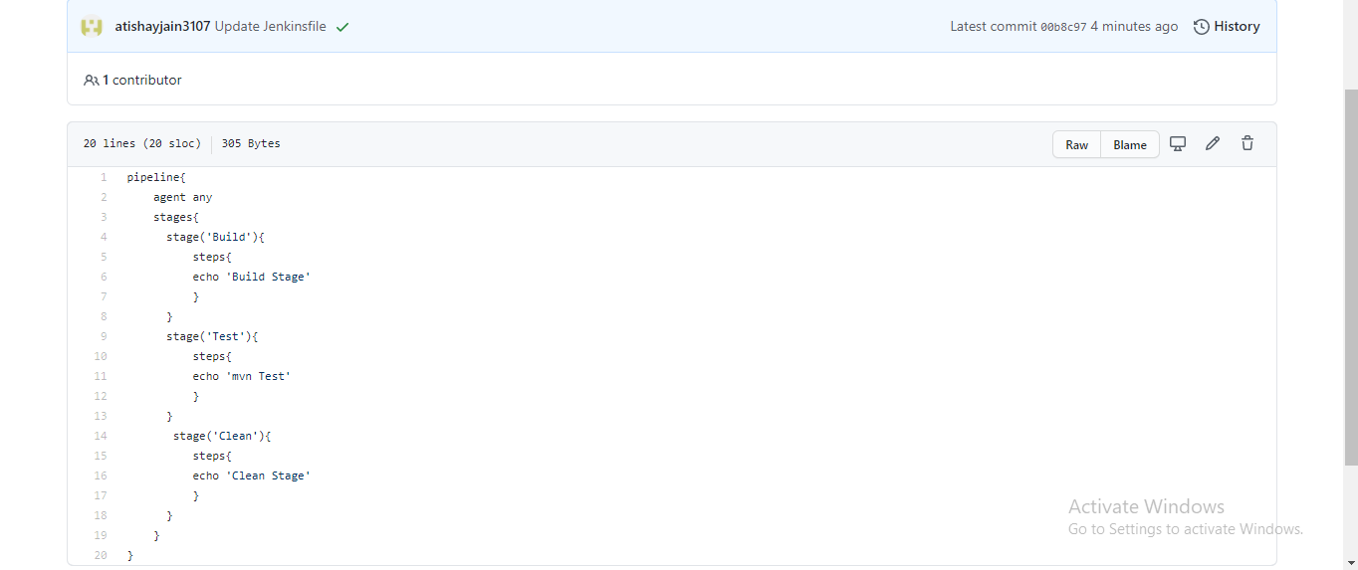

1. Something similar will appear showing a pipeline has been created

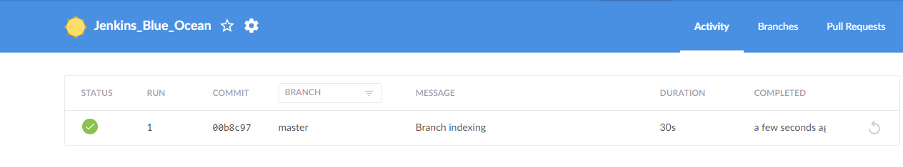

1. Click on this and you’ll see that a pipeline has been created successful

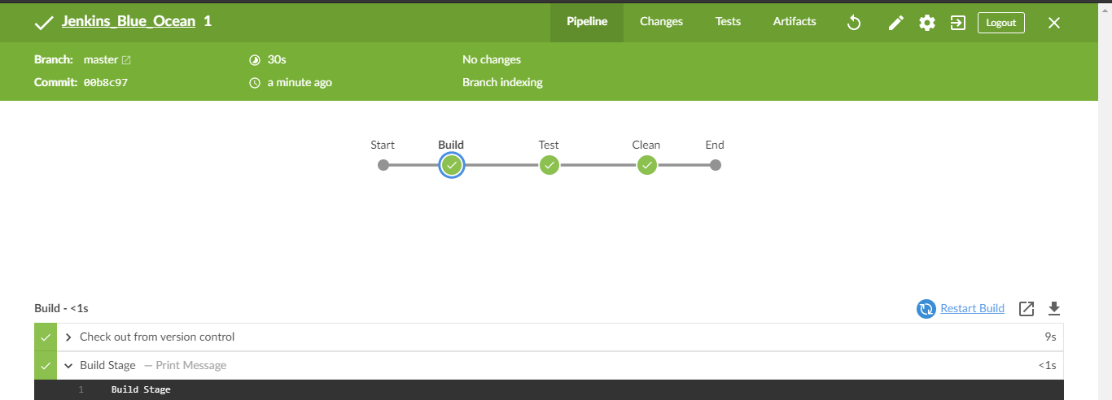

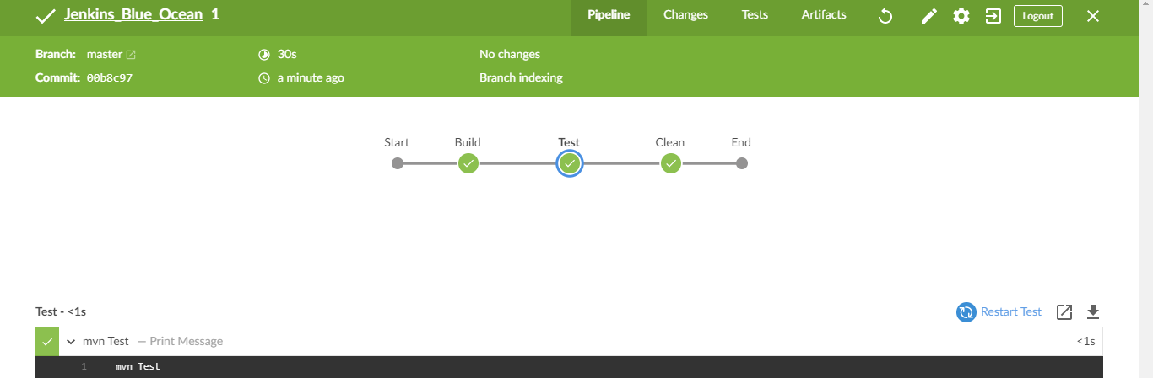

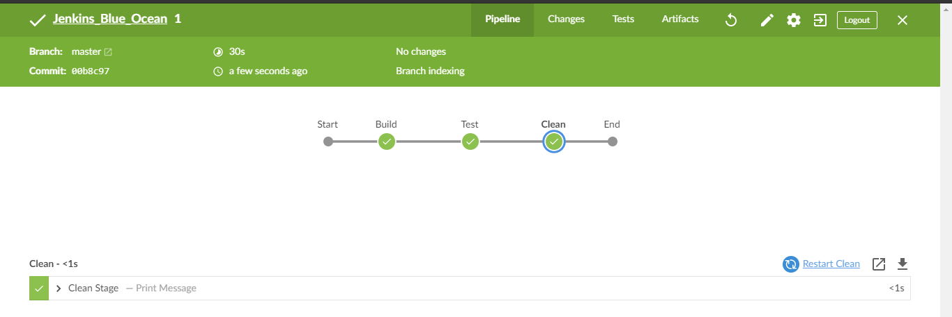

ATISHAY JAIN

500067694

R171218030

CSE, DEVOPS